Module 3 – Charts and Graphs in Tableau
3.1 Basic Charts in Tableau

1. Histogram
A Histogram shows the distribution of numerical data by grouping values into ranges (bins).
Example
Sales grouped into ranges:
- 0–1000
- 1000–2000
- 2000–3000
Use Case
- Analyze salary distribution
- Product sales distribution
- Student marks analysis
Steps in Tableau
- Open Tableau Public
- Connect dataset
- Drag numeric field (Example: Sales)
- Click Show Me
- Select Histogram
Output
Bars show frequency of values.
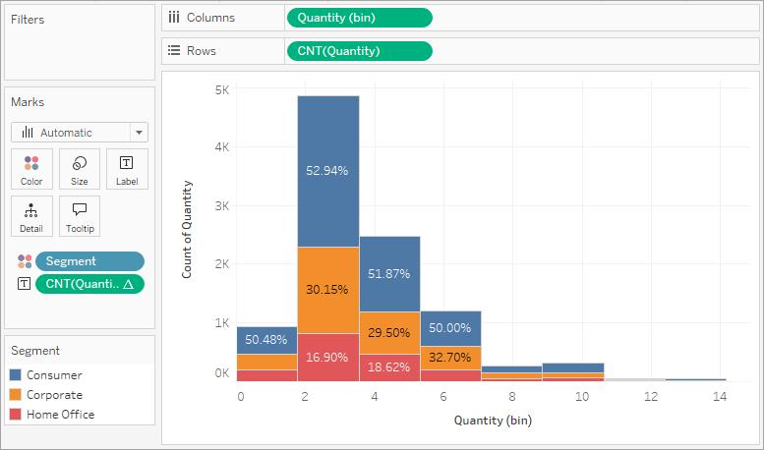
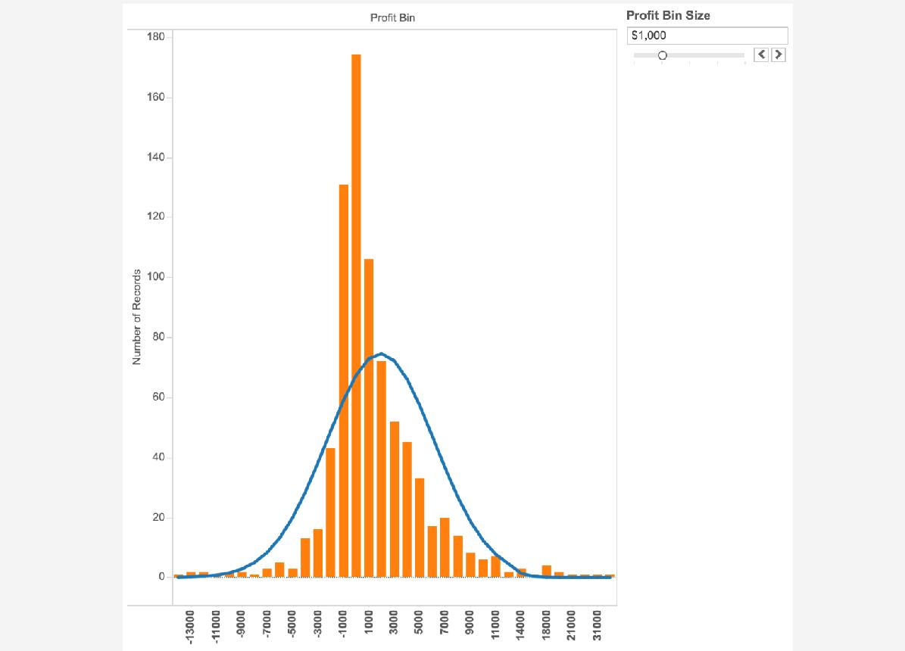
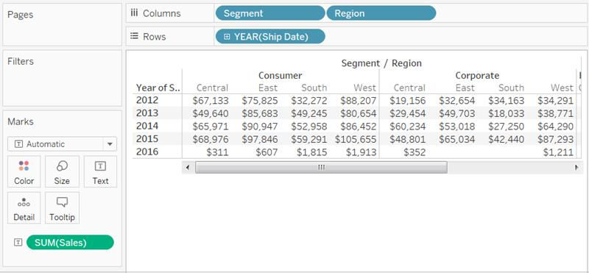

2. Box Plot
A Box Plot displays:
- Minimum
- Maximum
- Median
- Quartiles
- Outliers
Use Case
Used to detect unusual values (outliers).
Example
Employee salary comparison between departments.
Steps
- Drag Category → Columns
- Drag Sales → Rows
- Click Show Me
- Select Box-and-Whisker Plot
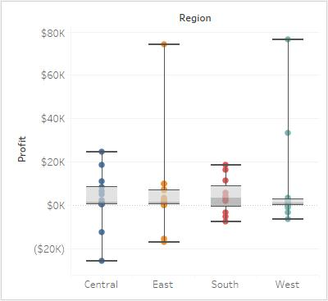
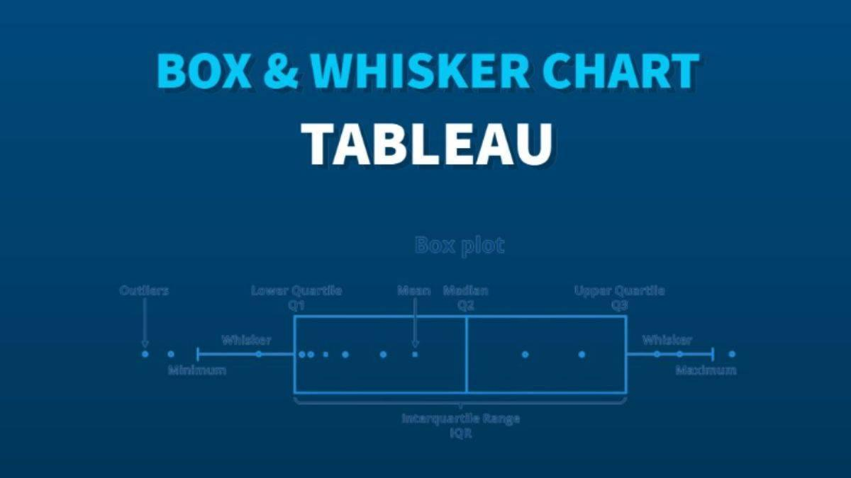
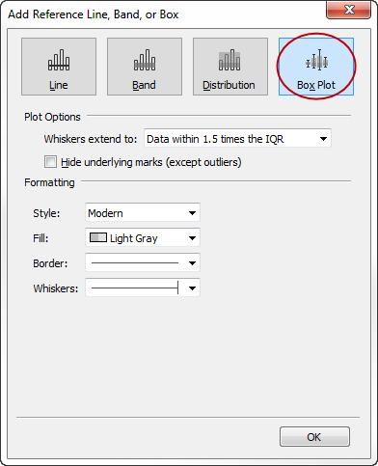

3. Motion Chart
A Motion chart shows data movement over time.
Example
Country population growth year by year.
Use Case
Trend analysis over time.
Steps
- Add Year to Pages shelf
- Add Sales to Rows
- Add Profit to Columns
- Add Category to Color/Detail
- Press Play

4. Pie Chart
A Pie chart shows percentage contribution.
Example
Market share of companies.
Steps
- Select dimension + measure
- Choose Pie Chart from Show Me
Best For
Small number of categories.
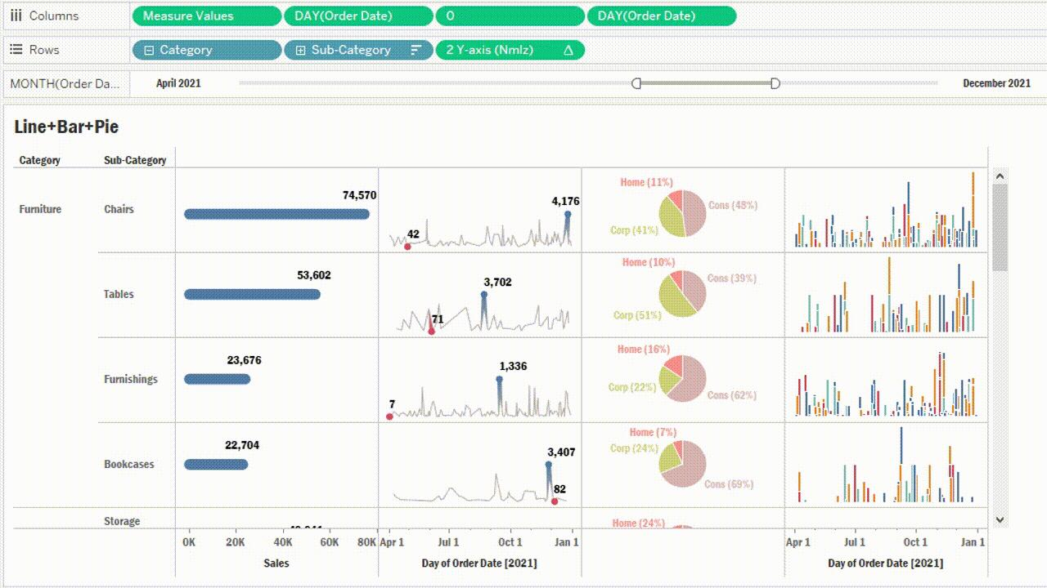
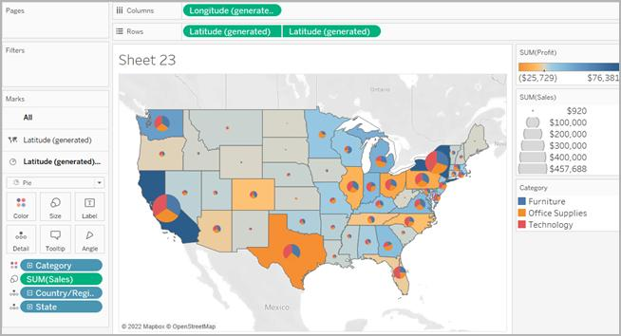
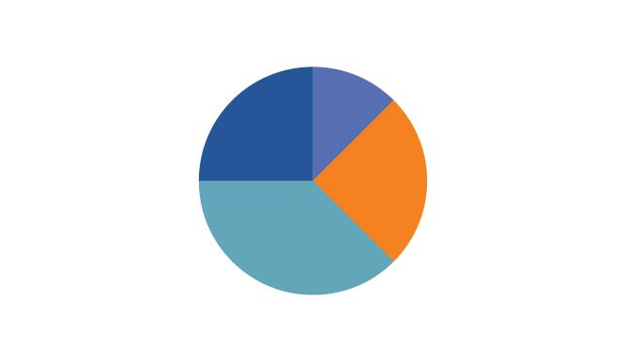

5. Bar Chart
Most commonly used chart.
Example
Sales by Region.
Steps
- Drag Region → Columns
- Drag Sales → Rows
Best For
Comparing categories.
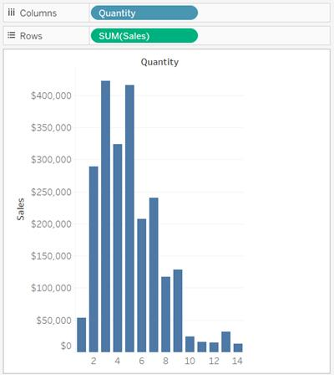
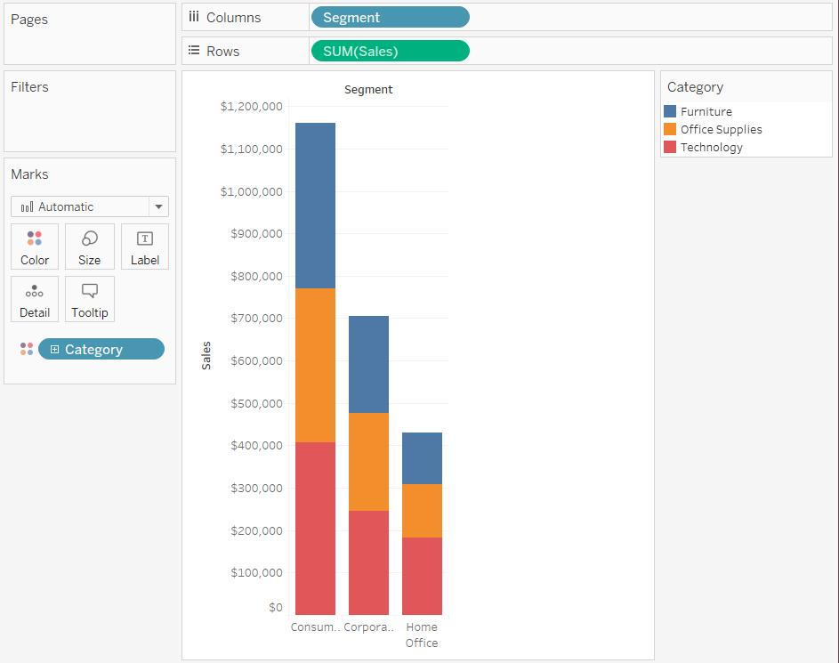
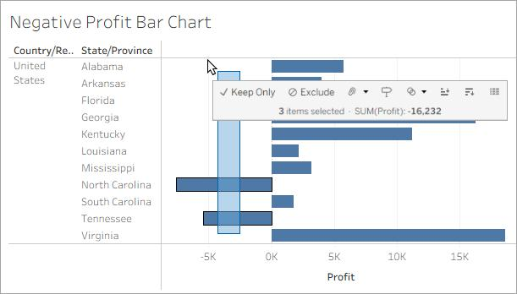

6. Line Chart
Shows trends over time.
Example
Monthly sales trend.
Steps
- Drag Date → Columns
- Drag Sales → Rows
- Choose Line Chart
Best For
Time-series analysis.
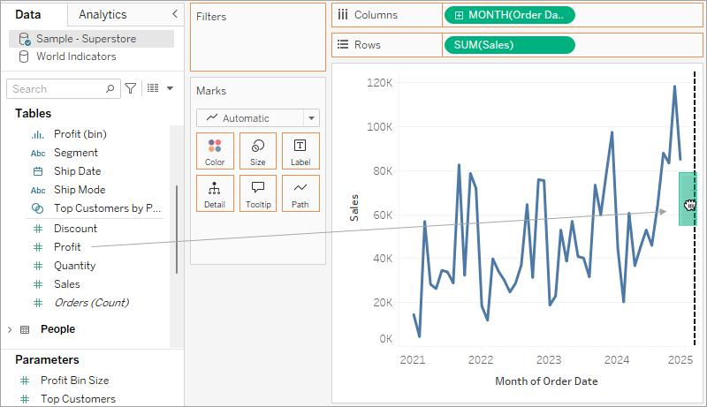
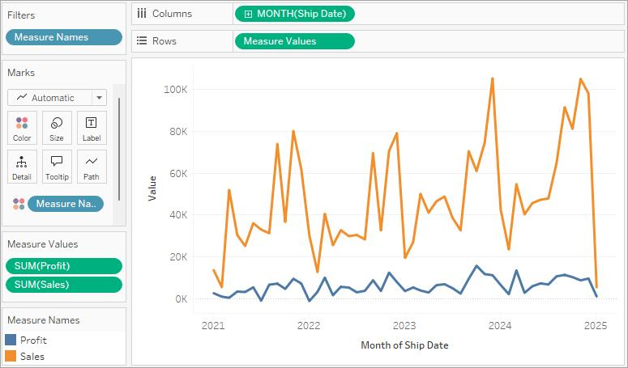
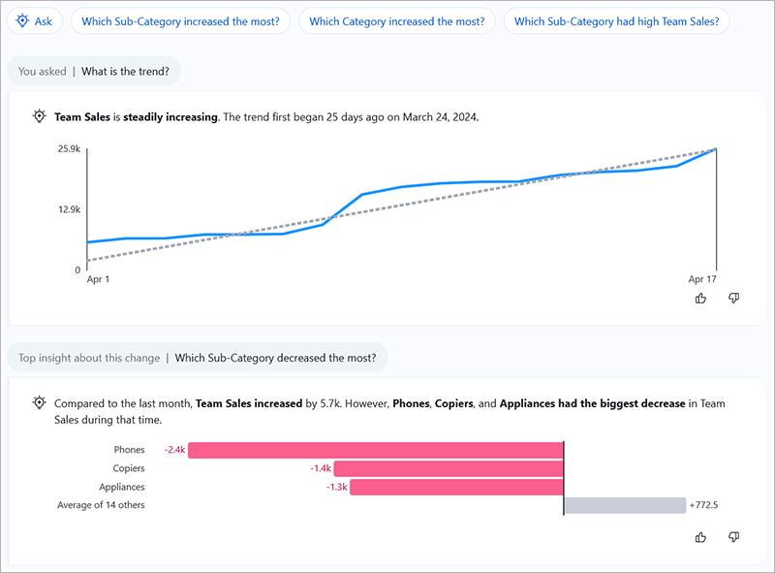

7. Bubble Chart
Represents data using circles.
Example
Sales vs Profit by category.
Steps
- Select Packed Bubbles from Show Me
- Add measure to Size and Color

8. Bullet Chart
Compares actual performance against target.
Example
Actual Sales vs Target Sales.
Best For
KPI dashboards.

9. Scatter Plot
Shows relationship between two measures.
Example
Advertising Spend vs Sales.
Steps
- Drag Profit → Columns
- Drag Sales → Rows
Best For
Correlation analysis.
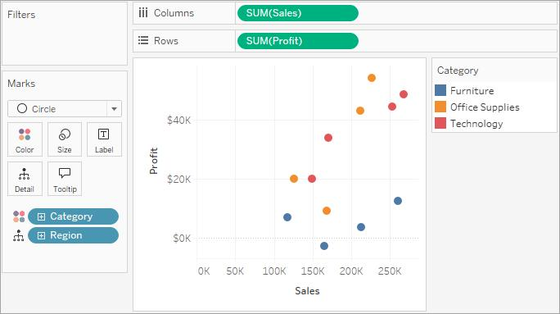
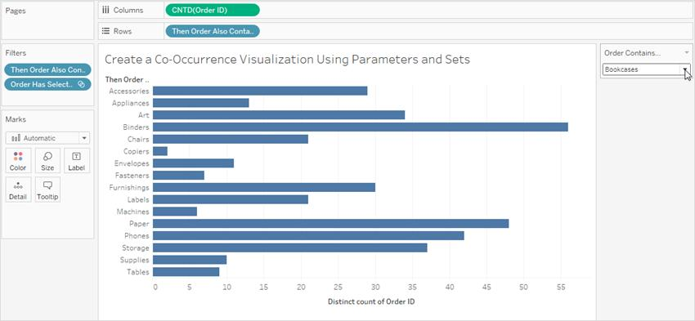
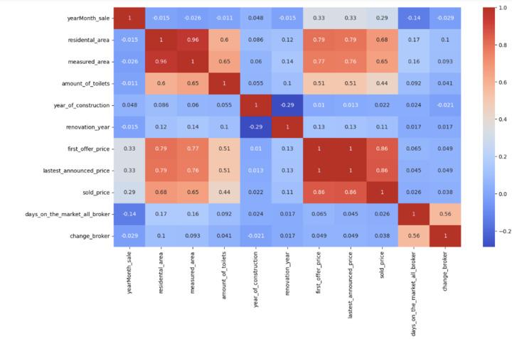

10. Tree Map
Displays hierarchical data using rectangles.
Example
Sales by Category and Sub-category.
Steps
- Drag Category and Sub-category
- Select Treemap from Show Me
Best For
Part-to-whole comparison.
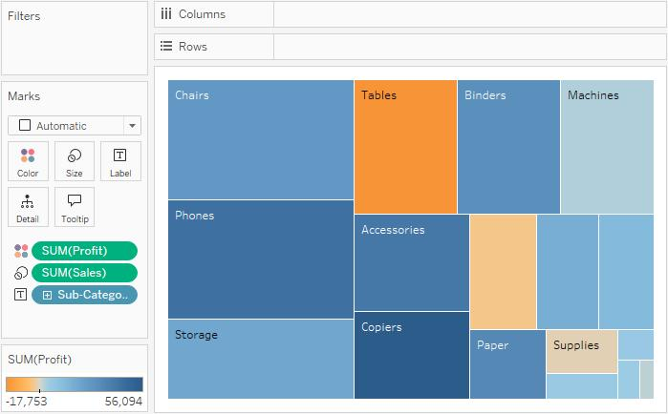
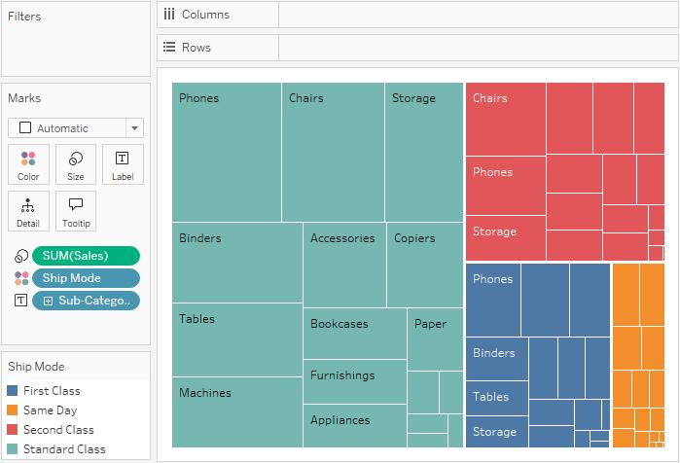
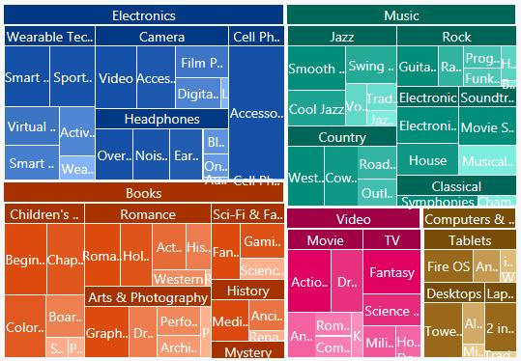

11. Heat Map
Uses colors to represent values.
Example
Sales by Region and Category.
Steps
- Drag Sub-Category → Rows
- Drag Region → Columns
- Change to Square→ Marks
- Drag Profit →Color
Best For
Finding high and low values quickly.
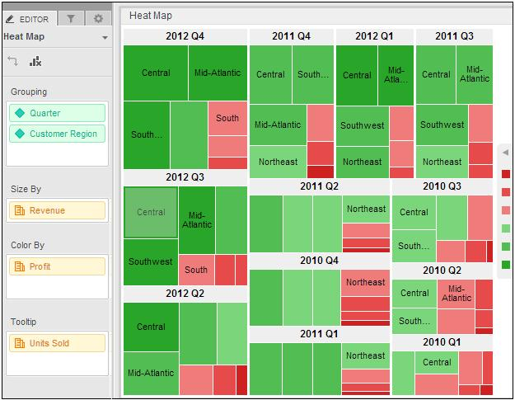
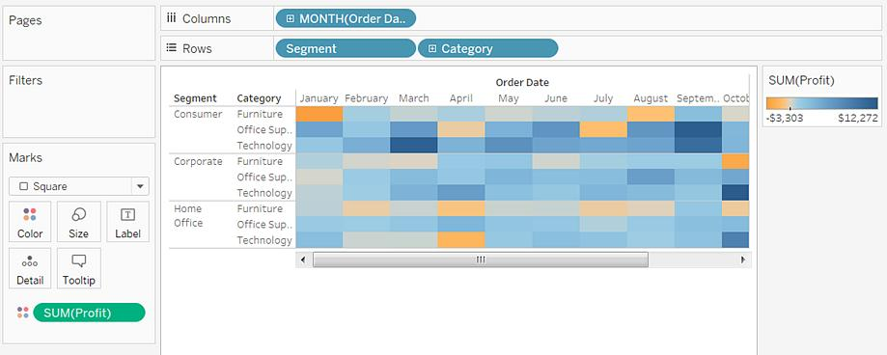
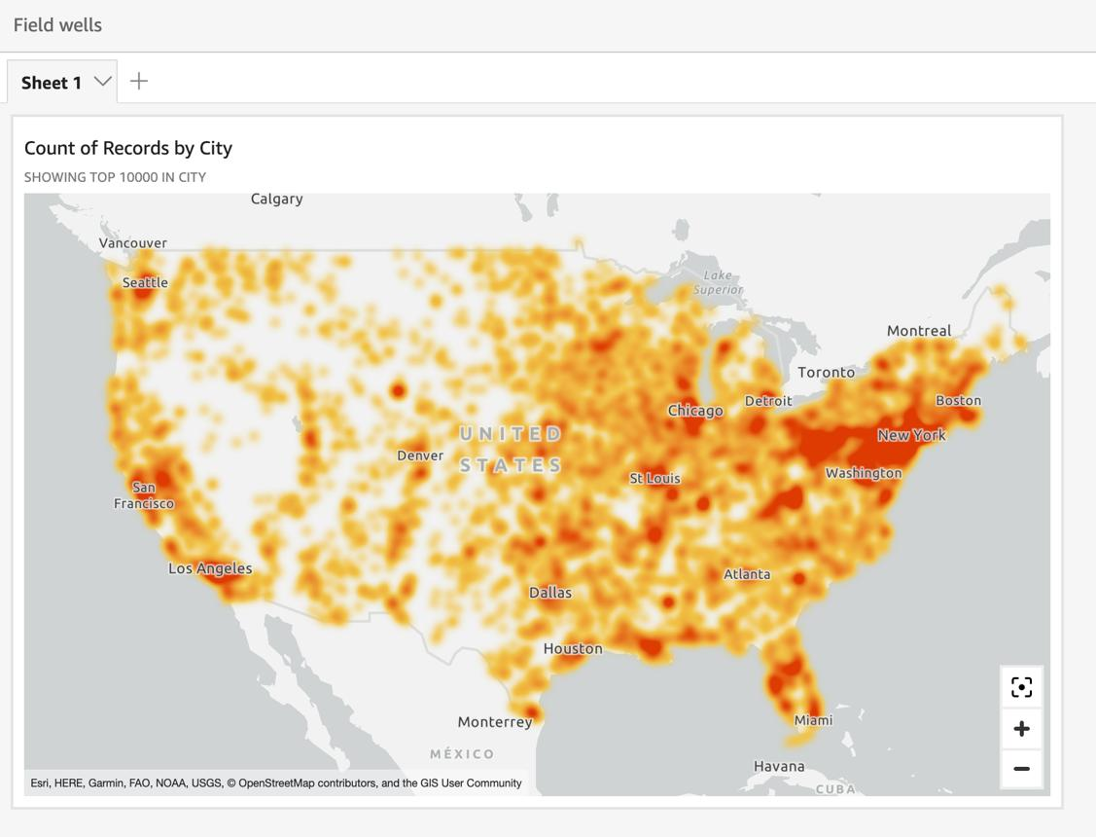

12. Maps
Used for geographic analysis.
Example
State-wise sales.
Steps
- Drag Country/State field
- Tableau automatically creates map
Best For
Location analysis.
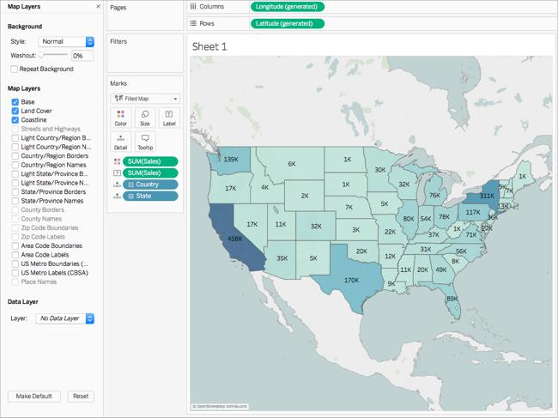
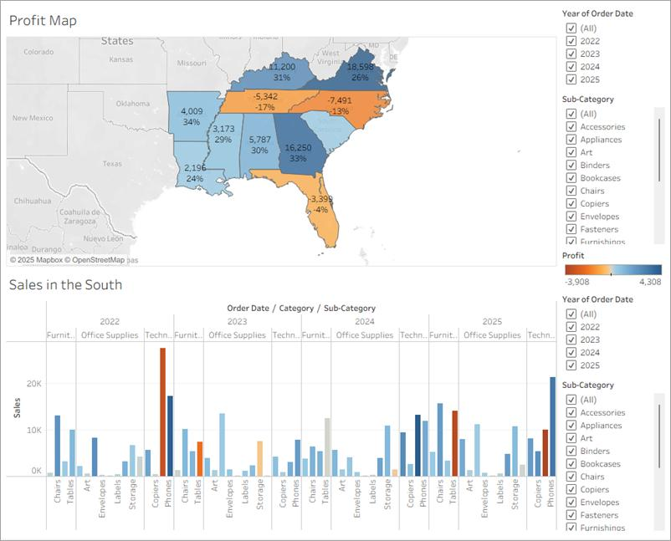
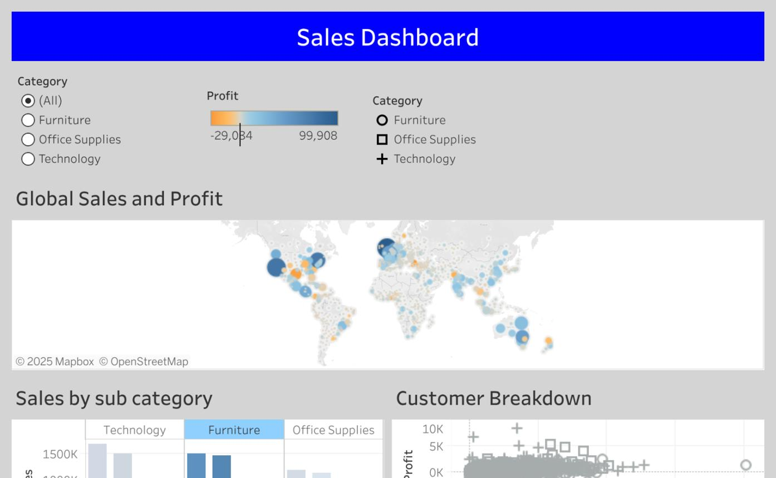

13. Text Table
Displays data in table format.
Example
Sales report by region.
Steps
- Drag dimensions to Rows/Columns
- Drag measure to Text

14. Highlighted Table
A text table with colors.
Example
High sales highlighted in dark color.
Steps
- Create text table
- Drag measure to Color

3.2 Dual Axes Graphs
A Dual Axis Chart combines two charts in one graph.
Example
Sales and Profit together.
Steps
- Drag Sales → Rows
- Drag Profit → Rows
- Right-click second axis
- Select Dual Axis
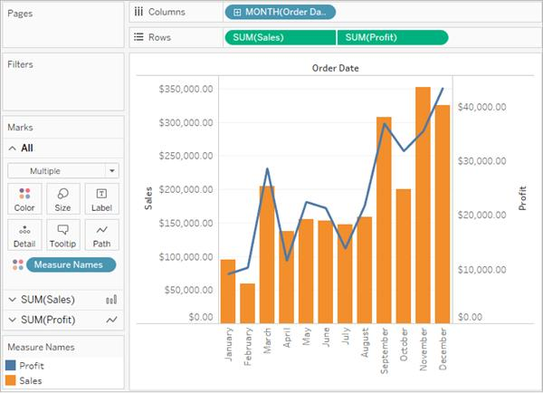
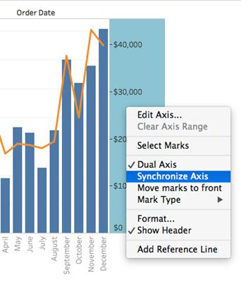
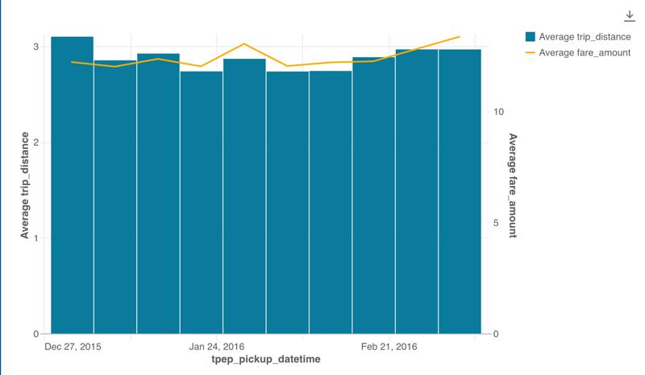

Pareto Chart
A Pareto chart combines:
- Bar chart
- Line chart
Based on the 80/20 rule.
Example
20% products generate 80% sales.
Steps
- Create bar chart
- Add running total line
- Use Dual Axis
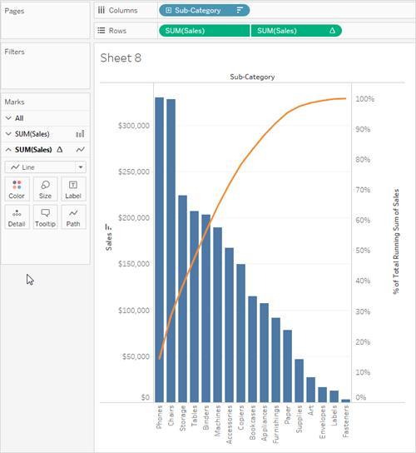

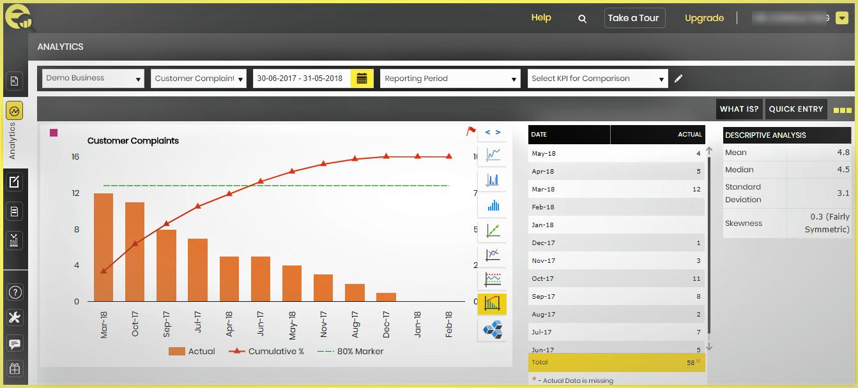

Funnel Chart
Represents stages in a process.
Example
Sales Funnel:
- Leads
- Qualified
- Proposal
- Closed
Steps
- Create bar chart
- Reverse axis
- Adjust size
Best For
Sales and recruitment analysis.
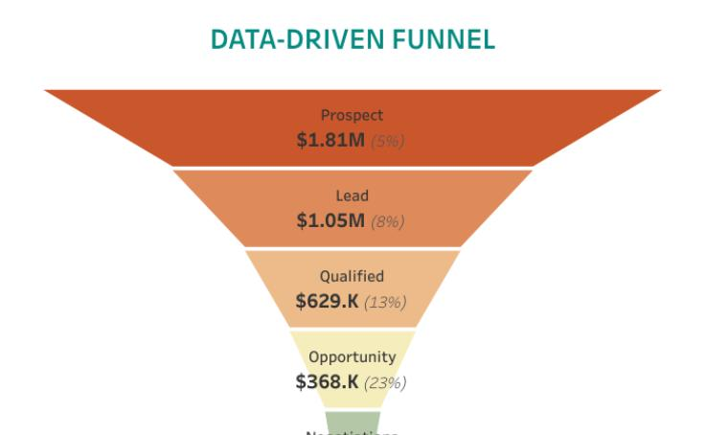
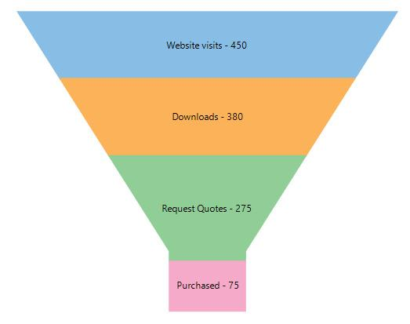
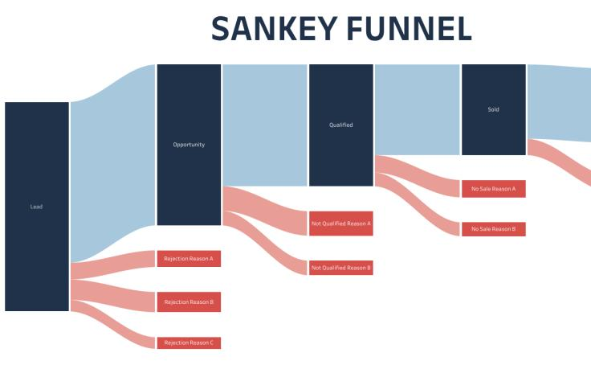

Waterfall Chart
Shows cumulative effect of increases/decreases.
Example
Revenue and expenses.
Step — Drag Order Date
- Drag Order Date → Columns
- From dropdown choose:
  - MONTH(Order Date)
You will see months on X-axis.

Step 3 — Drag Profit
- Drag Profit → Rows
You will get a line/bar chart.

Step 4 — Change Marks Type
On the Marks card:
- Open dropdown
- Select Gantt Bar
This is the important step for waterfall chart.

Step 5 — Create Running Total
Right-click Profit on Rows:
Quick Table Calculation
→ Running Total
Now Tableau creates cumulative profit.

Step 6 — Create Size Measure
Drag Profit again to:
Marks Card → Size
This creates the floating waterfall bars.

Step 7 — Adjust Bar Size
Use the Size slider on Marks card to increase width.

Step 8 — Add Color (Optional)
Drag Profit → Color
- Positive values = one color
- Negative values = another color
This clearly shows increase/decrease effect.

Best For
Financial analysis.
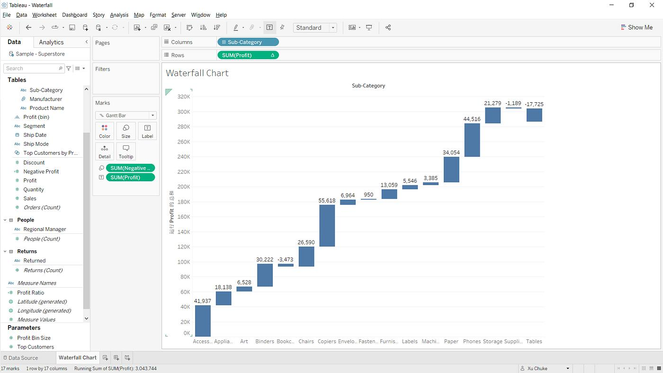
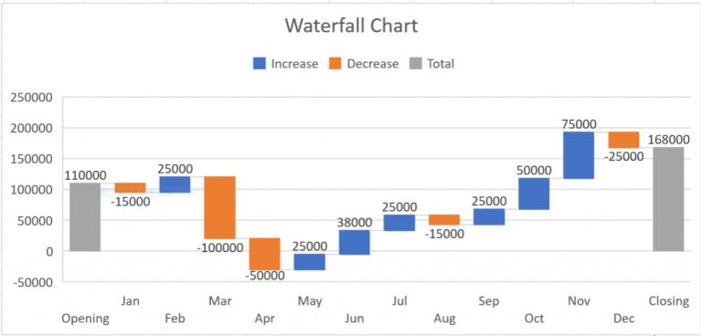
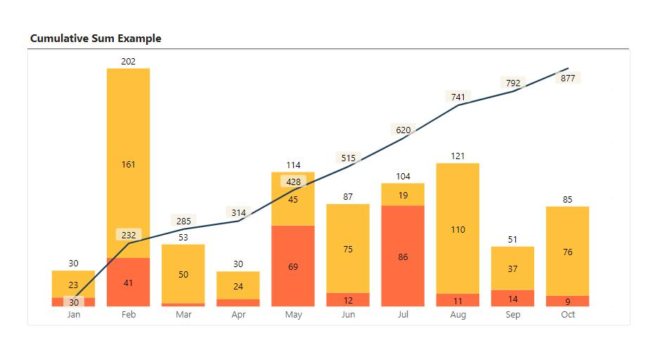

Market Basket Analysis (MBA)
Market Basket Analysis identifies products frequently purchased together.
Example
Customers buying:
- Bread → Butter
- Laptop → Mouse
- Phone → Charger
Business Use
- Product recommendation
- Cross-selling
- Store arrangement

MBA Important Terms
Term | Meaning
Support | Frequency of item combination
Confidence | Probability of buying second item
Lift | Strength of relationship

MBA Example
Transaction ID | Products
1 | Bread, Butter
2 | Bread, Milk
3 | Bread, Butter, Milk
4 | Butter, Milk
Rule Found
Bread → Butter

Steps to Perform MBA in Tableau
Step 1: Connect Dataset
Dataset columns:
- Transaction_ID
- Product_Name
Step 2: Self Join Dataset
Join table with itself using:
Transaction_ID = Transaction_ID
Step 3: Remove Same Product Pairs
Filter:
Product A ≠ Product B
Step 4: Count Product Combinations
Use COUNT(Transaction_ID)
Step 5: Create Heat Map or Table
Display:
- Product A
- Product B
- Frequency

Hands-on Exercise
Exercise 1
Using Sales Dataset:
Create:
- Histogram
- Tree Map
- Heat Map
- Funnel Chart
- Scatter Plot
- Pie Chart

Exercise 2
Perform MBA on Superstore Dataset:
Find:
- Frequently bought products
- Top product combinations

Sample Dataset for Practice
Order ID | Category | Sub-Category | Sales | Profit | Region
101 | Furniture | Chair | 5000 | 500 | East
102 | Technology | Laptop | 45000 | 8000 | West
103 | Office Supplies | Paper | 500 | 100 | South

Interview Questions
Q1. Difference between Heat Map and Tree Map?
- Heat Map uses colors
- Tree Map uses rectangle size
Q2. What is Dual Axis?
Combining two measures in one chart.
Q3. What is Pareto Principle?
80% results come from 20% causes.
Q4. What is MBA?
Technique to identify product purchase combinations.

